***Experiment 4 :-*** ***Design a smart phone controlled light system***

***Circuit Diagram:-***

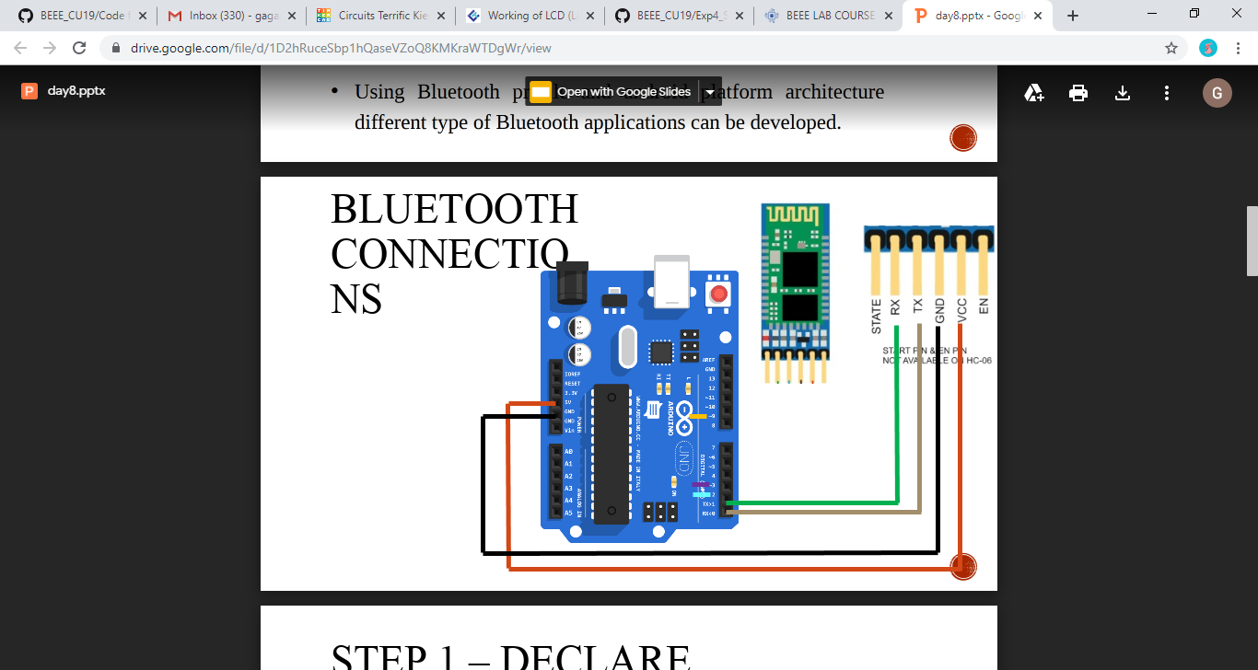

***Theory:-***

***Concept Used :-***The concept used is of the working of Bluetooth.Bluetooth technology is a wireless technology and it is used to transfer the data between one device to another device . HC-05 Bluetooth Module is a serial port protocol module and it is used to communicate with the Arduino with the help of serial communication. The HC-05 Bluetooth module consists of 6 pins from these pins we are using only 4 pins.

With the help of Bluetooth we command the led to get ON or OFF.

***HC-05 Technical Specifications***

* *Serial Bluetooth module for [Arduino](https://components101.com/microcontrollers/arduino-uno) and other microcontrollers*
* *Operating Voltage: 4V to 6V (Typically +5V)*
* *Operating Current: 30mA*
* *Range: <100m*
* *Works with Serial communication (USART) and TTL compatible*
* *Follows IEEE 802.15.1 standardized protocol*
* *Uses Frequency-Hopping Spread spectrum (FHSS)*
* *Can operate in Master, Slave or Master/Slave mode*
* *Can be easily interfaced with Laptop or Mobile phones with Bluetooth*

***Learning and Observations:-***

I learned how to interface Bluetooth with Arduino and control an led via Bluetooth connections. I learned about the different pins of Bluetooth and how actually the transferring and receiving of data takes place.

I observed that the led behaved as instructed by us using mobile app.

***Problems and Troubleshooting:-***

The problems encountered via making the circuit was of connections. The connections were loose so we made it tight and made the circuit work and achieved our desired result.

***Precautions:-***

* The connections should be tight.
* The connections should be accurate.
* The wires should be continuous.
* The led should be working and should be connected to a resistor to prevent it from damage.

***Learning Outcomes:-***

I learned how to interface Bluetooth with Arduino and control the functioning of led using commands from phone and also learned about the different pins of Bluetooth ,there functionality and how the whole transferring and receiving process takes place.